PROJECT MID TERM REPORT

On

**“Parking System”**

Six Months Industrial Training

At INFOWIZ, Chandigarh



<College logo>

**SUBMITED TO:- SUBMITTED BY:**

<lecture Name> <student name>

Class Roll No: <Branch>

**DECLARATION**

I hereby declare that the Industrial Training Report entitled ("Title of the project") is an authentic record of my own work as requirements of 6-months Industrial Training during the period from _______ to_______ for the award of degree of B.Tech.(Information Technology, **college name** under the guidance of (Name of Project Guide).

**(Signature of student)**

**(Name of Student)**

**(University Roll No.)**

**Date: ____________________**

**Head of Department**

**(Signature and Seal)**

*About ‘****INFOWIZ***

INFOWIZ was formed in 2009 with the mission to provide Industrial training to aspiring Engineersand technical support to industries. Within a short span of 9 years “Infowiz” has become one of the leading organizations which offer state of art professional IT solutions, Industrial trainings, technical support and consultancy to software companies in India and abroad. Due to quality assurance and high level of commitments in our services, we have won quite a few accolades and are associated with reputed universities and popular corporates, in the field.We strive to impart personalized, professional and contemporary experiential trainings on all the engineering streams that are necessary for the career, success and growth for both students & industry respectively.

**Business Overview**

Founded as industrial lab for providing industrial training to undergraduate engineers, “**Infowiz”** has grown progressively to become vertically integrated company in the industrial training arena. The core business of the company is to deliver range of industrial trainings in various engineering streams to students, IT solutions, software consultancy and support to small and big companies. **‘Infowiz’** enjoys the distinction of being Unique & Positive in the tri-city (Chandigarh, Panchkula Mohali) with extensive steams of softwares & engineering subjects. **“Infowiz”** is in a strong position to work with reputed Universities

**Company Strategy**

* **Vision:** To provide unique & high quality trainings that exceeds the expectations of our esteemed Students and Clients.
* **Purpose:** To be a leader in the Industrial training industry by providing enhanced relationship and profitability.
* **Mission statement:** To build long term relationships with our students and clients and provide exceptional customer services by pursuing business through innovation and advanced technology.

**Core Value**

* We believe in treating our students & customers with respect and faith,
* We grow through creativity, research and innovation,
* We integrate honesty, integrity and business ethics into all aspects of our business functioning

**Goals**

* Regional& National expansion in the field of trainings/software consultancy and develop a strong base of students & corporates.
* Increase the assets and investments of the company to support the development of services.
* To build good reputation in the field of Industrial trainings& software consultancy and become a key player in the industry.

**Accolades**

INFOWIZ won the **NATIONAL AWARD** for **3 consecutive years 2014-2015,2015-2016 & 2016-2017** for **BEST Industrial Training**

* **Best Education Provider Award 2017** from Punjab Education Minister S. Dalijit Singh Cheema.
* **Best Industrial Training Award 2016** from Honorable GOVERNER of Punjab & Haryana.
* **Best Industrial Training Award 2015** from Dr .Udit Raj (MP) & Mrs. Vimla Mehra (IPS Delhi)

**Product Portfolio**

* Web Development (PHP &.NET)
* JAVA (Core & Advance)
* Embedded systems (AVR, PIC & ARM)
* I-phone & Android application development
* Networking (MCSE,MCITP, CCNA, CCNP& RHSE)
* CCDP certification
* Robotics
* Ethical Hacking & Cloud Computing
* SEO & Bidding
* Automation ( Scada,PLC, Pannel,Drives )
* MATLAB
* AUTOCAD Civil and Mechanical (2D & 3D)
* Solid Works,Catia,Pro-E,NX-10,Cre-o,Cnc Programimg
* Staad Pro,3Ds MAX,Revit,Prima Vera
* C/C++/Data structure
* Short term/long term Industrial training
* Technical Support & Consultancy
* BBA,MBA (MARKETING,HR & FINANCE)

**Business Information**

* ***Business Type***: Industrial Training on Engineering courses, IT Solutions, Implementation
* ***State***: Chandigarh (UT)
* **Location*(s)***: Chandigarh, Bhatinda
* **Country:** India
* ***Employee Count***: 50 (Including CEO & MD)
* ***Delivery Lead-time:*** depend on the type of course and training
* ***Business Name***: INFOWIZ
* ***Business Address***: SCO 118-120, Basement, Sector 34A, Chandigarh   
  ***Business Email***: [info@infowiz.co.in](mailto:info@infowiz.co.in)
* ***Business Tel:***+91[172-4567-88](tel:172-4567-888)  +91 9888-500-888 +91 9888-600-888

**Principal Customer**

|  |  |  |  |
| --- | --- | --- | --- |
| **Sno.** | **Projects** | **URL's** | **Country** |
| **1** | *Viva Sales* | [*www.infowiz.in/vivasales*](http://www.infowiz.in/vivasales) | UK |
| **2** | *Mds Creative* | [*www.mdscreative.com*](http://www.mdscreative.com/) | Germany |
| **3** | *Liddle TV* | [*www.filmon.com*](http://www.filmon.com/) | UK |
| **4** | *Paradigms(Android)* | *Ongoing* | Australia |
| **5** | *Printcost* | [*www.popgraphics.net*](http://www.popgraphics.net/) | UK |
| **6** | *PSTDO Bootstrap* | [*www.bootstrap.achieversperfect.com*](http://www.bootstrap.achieversperfect.com/) | USA |
| **7** | *Essencesoftwares* | [*www.essencesoftwares.com*](http://www.essencesoftwares.com/) | Australia |
| **8** | *Dashboard (WordPress)* | *Ongoing* | USA |
| **9** | *Realstate* | [*www.realstate.infowiz.in*](http://www.realstate.infowiz.in/) | Russia |
| **10** | *Dealpartners(WordPress)* | [*www.dealpartners.co.uk.gridhosted.co.uk*](http://www.dealpartners.co.uk.gridhosted.co.uk/) | UK |

INFOWIZ is led by a team of professionals and technicians who are honest, committed and always ready to accept contemporary challenges. The leadership roles are

**1.Mr. Kamaljot Kansal (CEO)**

Mr. Kansal has been turning ideas into realities ever since he has taken up the task of promoting INFOWIZ. In his own words “*I never dreamt about success I worked for It.*” reflects that he believes in talk less and work more theory. No doubt under his leadership INFOWIZ has become one of strongest companies in the field of IT solutions in less than a decade.His management fundamental is “team work” as he takes along, talks along all his team members and appreciates and attributes their contribution to the success of INFOWIZ. He is determined to bring Infowiz in the top 5 companies in the country.

**ROADMAP OF FUTURE**

***INFOWIZ’s*** future plans include regional and national expansion through both COCO and FOFO business models. Our 1st COCO branch is already operational at Bhatinda. Being an ISO certified company and member of CII we have attained very high level of accomplishments in the Industrial training business that we would want to take to masses. Infowiz is committed to develop its strengths & core competencies with continues research & technical excellence. It would never cease to embrace and add latest technological advancements in the field of trainings and pass the same to the students as and when demand will arise, creating the best and most modern atmosphere for learning.

**\**

**Introduction to Java:**

* In 1990, Sun Microsystems Inc. (US) was conceived a project to develop software for customer electronics devices that could be controlled by a remote. This project was called Stealth Project but later its name was changed to Green Project. In 1991, Bill Joy, James Gosling, and several others met in Aspen, Colorado to discuss this project. James Gosling was to identify the proper programming language for the project. Gosling thought C and C++ could be used to develop the project. But the problem they faced with them is that they were system dependent languages and hence could not be used on various processors, which the electronic devices might use. So started developing a new language, which was completely system independent. This language was initially called Oak. Since this name was registered by some other company, later it was changed to Java.
* Why the name Java? James Gosling and his team members were consuming a lot of coffee while developing this language. They felt that they were able to develop a better language because of the good quality coffee they consumed. So the coffee had its own role in developing this language and good quality coffee was exported to the entire world from a place called ‘Java Island’. Hence they fixed the name of the place for the language as Java. And the symbol for Java language is coffee cup and saucer.
* On Jan 23rd 1996, JDK 1.0 version was released. Today more than 4 million developers use Java and more than 1.75 billion devices run Java. Thus Java was pervaded the world. Java is software that enables users to run program on any type of computer system. Java is suitable for internet because of its independency. It eliminates a lot of security problems for data on internet. It is purely object-oriented language. This means Java program use classes and objects. Because of its lot of features we create our project report of Hospital Management System in this language.

**Java History:**

* Java is a general-purpose, object-oriented programming language developed by Sun Microsystems of USA in 1991.Originally called Oak by James Gosling (one of the inventor of the language). Java was invented for the development of software for consumer electronic devices like TVs etc. The main aim had to make java simple, portable and reliable.

**Following data shows the year and beginning of Java**

**1990**

* Sun decided to developed software that could be used for electronic devices. And the project called as Green Project head by James Gosling.

**1991**

* Announcement of a new language named ―Oak‖

**1992**

* The team verified the application of their new language to manage a list of home appliances using a hand held device.

**1993**

* The World Wide Web appeared on the Internet and transformed the text-based interface to a graphical rich environment.

**1994**

* The team developed a new Web browsed called ―Hot Java‖ to locate and run Applets.

**1995**

* Oak was renamed to Java, as it did not survive ―legal‖ registration. Many companies such as Netscape and Microsoft announced their support for Java.

**1996**

* Java language is now famous for Internet programming as well as a general purpose OO language.

**1997**

* Sun releases Java Development Kit(JDK 1.1)

**1998**

* Sun releases Software Development Kit (SDK 1.2)

**1999**

* Sun releases Java 2 platform Standard Edition (J2SE) and Enterprise Edition(J2EE).

**2000**

* J2SE with SDK 1.3 was released.

**Features of Java:**

* Apart from being a system independent language, there are other reasons too for the immense popularity of this language. Let us have a look at some of its features.
  1. Simple
  2. Object- oriented
  3. Distributed
  4. Robust and secure
  5. System Independence
  6. Scalability
  7. High performance
  8. Compiled and Interpreted
  9. Platform Independent and portable
  10. Simple and small
  11. Multithreaded and Interactive

**Simple:**

* Java is a simple programming language. Rather than saying that this is the feature of Java, we can say that is the design aim of Java. When Java is developed, they wanted it to be simple because it has to work on electronic devices, where less memory is available. Now, the question is how Java is made simple? First of all, the difficult concepts of C and C++ have been omitted in Java. Next, Java Soft people maintained the same syntax of C and C++ in Java, so that a programmer who knows C or C++ will find Java already familiar.

**Object-Oriented:**

* Java is an object-oriented programming language. This means Java programs use objects and classes. What is an object? An object is anything that really exists I the world and can be distinguished from others. Everything that we see physically will come into this definition, for example, every human being, a book, a tree, and so on.
* A group of objects exhibiting same behavior will come under the same group called a class. A class represents a group name given to several objects. For example, take the dogs: Pinky, Nancy, Tom and Subbu. All of these dogs have same behavior and hence belong to the same group, called dog. So dog is the class name which contains 4 objects.

**Distributed:**

* Information is distributed on various computers on a network. Using Java, we can write programs, which capture information and distribute it in to the clients. This is possible because Java can handle the protocols like TCP/IP and UDP.

**Robust and secure:**

* Java is a most strong language which provides many securities to make certain reliable code. It is design as garbage –collected language, which helps the programmers virtually from all memory management problems. Java also includes the concept of exception handling, which detain serious errors and reduces all kind of threat of crashing the system.
* Security is an important feature of Java and this is the strong reason that programmer use this language for programming on Internet.
* The absence of pointers in Java ensures that programs cannot get right of entry to memory location without proper approval.

**System Independence:**

* Java’s byte code is not machine dependent. It can be on any machine with any processor and any operating system.

**Scalability:**

* Java platform can be implemented on a wide range of computers with varying levels of resources-from embedded devices to mainframe computers. This is possible because Java is compact and platform independent.

**High Performance:**

* The problem with interpreter inside the JVM is that it is slow. Because of this, Java programs used to run slow. To overcome this problem, along with the interpreter Java Soft people have introduced JIT compiler, which enhances the speed of execution. So now in JVM, both interpreter and JIT compiler work together to run the program.

**Compiled and Interpreted**

* Basically a computer language is either compiled or interpreted. Java comes together both these approach thus making Java a two-stage system.
* Java compiler translates Java code to Bytecode instructions and Java Interpreter generate machine code that can be directly executed by machine that is running the Java program.

**Platform Independent and portable**

* Java supports the feature portability. Java programs can be easily moved from one computer system to another and anywhere. Changes and upgrades in operating systems, processors and system resources will not force any alteration in Java programs. This is reason why Java has become a trendy language for programming on Internet which interconnects different kind of systems worldwide. Java certifies portability in two ways.
* First way is, Java compiler generates the bytecode and that can be executed on any machine. Second way is, size of primitive data types are machine independent.

**Simple and small**

* Java is very small and simple language. Java does not use pointer and header files, goto statements, etc. It eliminates operator overloading and multiple inheritance.

**Multithreaded and Interactive**

* Multithreaded means managing multiple tasks simultaneously. Java maintains multithreaded programs. That means we need not wait for the application to complete one task before starting next task. This feature is helpful for graphic applications.

**Parts of Java:**

* Sun Microsystems Inc. has divided Java into 3 parts-Java SE, Java EE and Java ME.

**Java SE:**

* It is the Java Standard Edition that contains basic core Java classes. This edition is used to develop standard applets and applications.

**Java EE:**

* It is the Java Enterprise edition and it contains classes that are beyond Java SE. In fact, we need Java SE in order to use many of the classes in Java EE. Java EE mainly concentrates on providing business solutions on a network.

**Java ME:**

* It is the Java Micro Edition. Java ME is for developers who develop code for portable devices, such as a PDA or a cellular phone. Code on these devices needs to be small in size and should take less memory.

**Basic Concept of OOPS(Object-Oriented Programming):**

* There are some basic concepts of object oriented programming as follows:

1. Object

2. Class

3. Data abstraction

4. Data encapsulation

5. Inheritance

6. Polymorphism

7. Dynamic binding

**1 .Objects**

* Objects are important runtime entities in object oriented method. They may characterize a location, a bank account, and a table of data or any entry that the program must handle.

**2 .Classes**

* A class is a set of objects with similar properties (attributes), common behaviour (operations), and common link to other objects. The complete set of data and code of an object can be made a user defined data type with the help of class.
* The objects are variable of type class. A class is a collection of objects of similar type. Classes are user defined data types and work like the build in type of the programming language. Once the class has been defined, we can make any number of objects belonging

**3 .Data Abstraction**

* Data abstraction refers to the act of representing important description without including the background details or explanations.
* Classes use the concept of abstraction and are defined as a list of abstract attributes such as size, cost and functions operate on these attributes. They summarize all the important properties of the objects that are to be created.
* Classes use the concepts of data abstraction and it is called as Abstract Data Type (ADT).

**4 .Data Encapsulation:**

* Data Encapsulation means wrapping of data and functions into a single unit (i.e. class). It is most useful feature of class. The data is not easy to get to the outside world and only those functions which are enclosed in the class can access it.
* These functions provide the boundary between Object‘s data and program. This insulation of data from direct access by the program is called as **Data hiding**.

**Technological Specifications**

**Polymorphism:**

* Polymorphism came fr the two Greek words ‘poly’ meaning many and morphos meaning forms. The ability to exist in different forms is called ‘polymorphism’. In Java, a variable, an object, or a method can exist in different forms, thus performing various tasks depending on the context. Because same variable or method can perform different tasks, the programmer has the advantage of writing flexible code.

**Abstract class:**

* An abstract class is a class that contains 0 or more abstract methods. It can contain instances variables and concrete methods in addition to abstract methods. It should be declared by the keyword ‘abstract’.

**Interfaces:**

* An interface contains only abstract methods which are all incomplete methods. So it is not possible to create an object to an interface. In this case, we can create separate classes where we can implement all the methods of the interface. These classes are called implementation classes.

**Packages:**

* It is necessary in software development to create several classes and interfaces. After creating these classes and interfaces, it is better if they are divided into some groups depending on their relationship. Thus, the classes and interfaces which handle similar or same task are put into the same directory. This directory or file is also called a package.

**Exception Handling:**

* When there is an exception, the user data may be corrupted. This should be tackle by the programmer by carefully designing the program. For example, if your application unsuccessfully tries to log into a database, it should not display an error message that includes the user name it is using.

**Java Virtual machine:**

As we know that all programming language compilers convert the source code to machine code.Same job done by Java Compiler to run a Java program, but the difference is that Java compiler convert the source code into Intermediate code is called as bytecode. This machine is called the Java Virtual machine and it exits only inside the computer memory.

**Following figure shows the process of compilation:**

JAVA

COMPILER

VIRTUAL

MACHINE

JAVA

PROGRAM

* The Virtual machine code is not machine specific. The machine specific code is generated. By Java interpreter by acting as an intermediary between the virtual machine and real machines shown below

VIRTUAL

MACHINE

JAVA

COMPILER

JAVA

PROGRAM

* Java Object Framework act as the intermediary between the user programs and the virtual machine which in turn act as the intermediary between the operating system and the Java Object Framework.

|  |
| --- |
| OPERATING SYSTEM |
| JAVA VIRTUAL MACHINE |
| JAVA OBJECT FRAMEWORK |
| COMPILER AND FRAMEWORK |
| USER APPLCATION PROGRAM |

**Fig: Layers of Interaction for Java programs**

**Java Environment:**

* Java environment includes a number of development tools, classes and methods. The development tools are part of the system known as Java Development Kit (JDK) and the classes and methods are part of the Java Standard Library (JSL), also known as the Application Programming Interface (API).
* Java Development kit (JDK) – The JDK comes with a set of tools that are used for developing and running Java program. It includes:

1. Appletviewer ( It is used for viewing the applet)

2. Javac (It is a Java Compiler)

3. Java (It is a java interpreter)

4. Javap (Java diassembler,which convert byte code into program description)

5. Javah (It is for java C header files)

6. Javadoc (It is for creating HTML document)

7. Jdb (It is Java debugger)

I**ntroduction of Project**

In the modern world, where parking-space has become a very big problem and in the era of miniaturization, it is become a very crucial necessity to avoid the wastage of space in modern, big companies and apartments etc. In places where more than 100 cars need to be parked, this system proves to be useful in reducing wastage of space. This Automatic Multi-Level Car Parking System enables the parking of vehicles, floor after floor and thus reducing the space used. Here any number of cars can be parked according to the requirement. This makes the system modernized and even a space-saving one.

Automatic Multi-Level Car Parking System provides an automatic parking mechanism which works as follow -

When any vehicle enters the parking facility it gets detected using some Infra-red sensors and gate is opened for vehicle entry and Vehicle Counter is incremented.

One Bi-Color Led which blinks Red if lift is busy or Green if lift is free and on ground floor ready to serve the next vehicle. Lift is equiped with multiple sensors for automatic operations and one button for returning condition.

On Green Signal vehicle must moved into the lift. When Lift detects the vechile placed in proper orientation, it starts moving and stops on the floor where slots for parking is available. Space Availablity on a particular floor is maintained on sensor basis. After the parking is done user has to  press a button on lift to come back down on ground floor.

Signal for a particular event is indicated timely by some Leds and a beeper. Parking System also include a LCD to display Important messages to user.

**Features**

* Car Counting System using Infra-Red Sensors.
* Automatic Door Opening using IR Sensors.
* Sensor based Lift System for moving vehicle to the right floor.
* Easy to use System.
* Multiple Floor to reduce space.

**CD Content**

* Project Report in Word and PDF format
* Circuit Diagram
* PCB Layout
* Micrcontroller Program in C-language
* Hex File(Binary Code)
* Software Tools and IDE
* Datasheet of all components and ICs used in project
* Video Introduction of Project
* Details of Assembling Guide and Working of Project
* **DISADVANTAGES OF CAR PARKING:-**
* Drivers who use multi parking facilities, sometimes known as parking garages, often enjoy a number of benefits the structures provide. Despite the ability of the garages to house a large number of cars, multi-story parking facilities also carry a number of distinct disadvantages that arise from their tall, enclosed and often dimly lit nature
* **1.Deterioration and Maintenance**
* Multi-story parking facilities support hundreds of thousands of pounds of vehicles, people and equipment every day. Because the garages support very large amounts of weight and loads that constantly change, the structures quickly deteriorate in the absence of constant maintenance activity. In addition, according to Canada’s National Resource Council, changing weather and environmental conditions can deteriorate a garage’s steel support structure, creating an unsafe environment for garage users. A number of corrosion inhibitors can help delay processes that eat away at the structure’s integrity, according to the National Resource Council, but constant maintenance and upkeep must include anti-corrosion measures to keep multi-story parking facilities structurally sound.

**2.Parking Angle Considerations**

Because many drivers of varying levels of skills and experience drive in, around and out of parking garages every day, designers must pay special attention to the configuration of parking spaces within the structures. In a municipal parking garage presentation prepared by architects Sakri and Khairuddin, the designers noted that two-way traffic flow in a multi-story garage presents a number of parking challenges for drivers and designers. Parallel parking, for example, creates an inefficient use of limited space, while straight parking spaces make parking difficult for some drivers. Other options, like angled parking, do not work well with a two-way traffic flow and can only work well in garages with separate entrance and exit openings.

**3.Lighting**

While most parking lots open at night, multi-story or otherwise, require some form of lighting, the multi-story nature of parking garages creates a need for numerous lights throughout the structure. In addition, because the inside of the structure may remain dark even during the day, many of these lights must run at all times. This arrangement can create high energy bills for garage owners and may require frequent lighting maintenance to replace broken or burned-out bulbs

When any vehicle enters the parking facility it gets detected using some Infra-red sensors and gate is opened for vehicle entry and Vehicle Counter is incremented.

One Bi-Color Led which blinks Red if lift is busy or Green if lift is free and on ground floor ready to serve the next vehicle. Lift is equiped with multiple sensors for automatic operations and one button for returning condition.

On Green Signal vehicle must moved into the lift. When Lift detects the vechile placed in proper orientation, it starts moving and stops on the floor where slots for parking is available. Space Availablity on a particular floor is maintained on sensor basis. After the parking is done user has to  press a button on lift to come back down on ground floor.

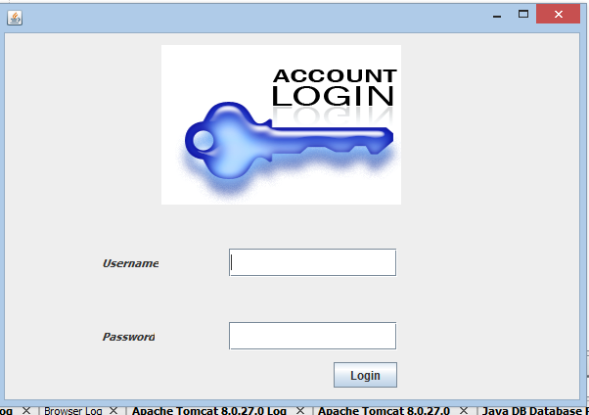



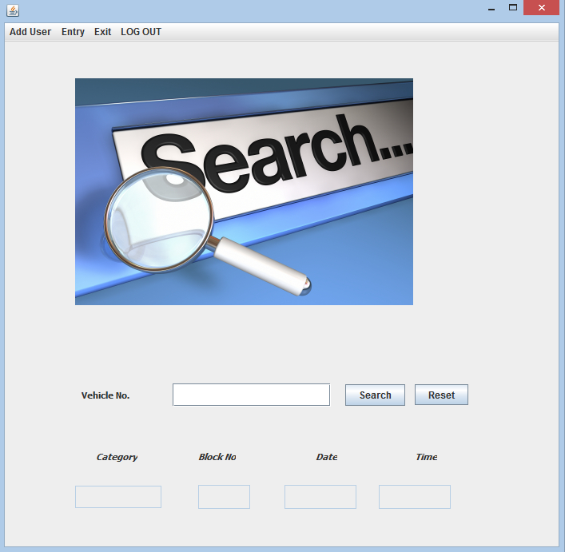

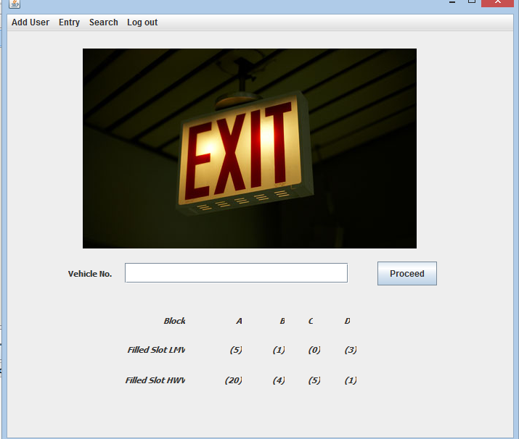

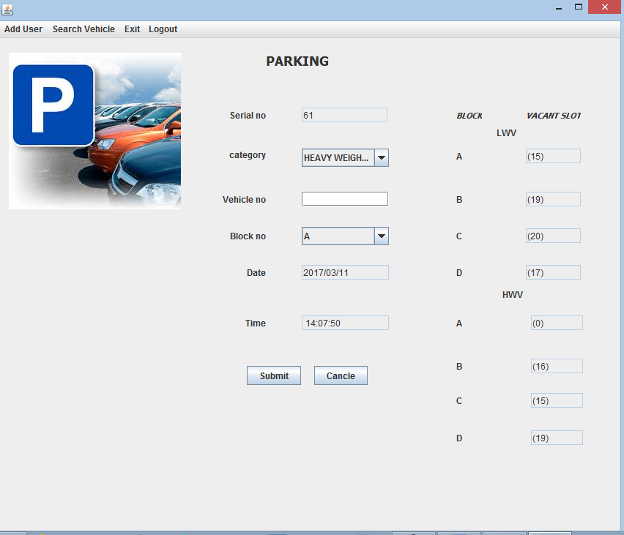

<div class="pull-left socialNw">

<a href="#"><span class="icon-twitter"></span></a>

<a href="#"><span class="icon-facebook"></span></a>

<a href="#"><span class="icon-youtube"></span></a>

<a href="#"><span class="icon-tumblr"></span></a>

</div>

<a href="index.jsp"> <span class="icon-home"></span> Home</a>

<a href="#"><span class="icon-user"></span> My Account</a>

<a href="register.jsp"><span class="icon-edit"></span> Free Register </a>

<a href="contact.jsp"><span class="icon-envelope"></span> Contact us</a>

<a href="cart.jsp"><span class="icon-shopping-cart"></span>0 Item(s) - <span class="badge badge-warning"></span></a>

</div>

</div>

</div>

</div>

<!--

Lower Header Section

-->

<div class="container">

<div id="gototop"> </div>

<header id="header">

<div class="row">

<div class="span4">

<h1>

<a class="logo" href="index.jsp"><span>Twitter Bootstrap ecommerce template</span>

<img src="assets/img/logo-bootstrap-shoping-cart.png" alt="bootstrap sexy shop">

</a>

</h1>

</div>

<div class="span4">

</div>

<div class="span4 alignR">

<p><br> <strong> Support (24/7) : 0800 1234 678 </strong><br><br></p>

<span class="btn btn-mini">[ 2 ] <span class="icon-shopping-cart"></span></span>

<span class="btn btn-warning btn-mini">$</span>

<span class="btn btn-mini">&pound;</span>

<span class="btn btn-mini">&euro;</span>

</div>

</div>

</header>

<!--

Navigation Bar Section

-->

<div class="navbar">

<div class="navbar-inner">

<div class="container">

<a data-target=".nav-collapse" data-toggle="collapse" class="btn btn-navbar">

<span class="icon-bar"></span>

<span class="icon-bar"></span>

<span class="icon-bar"></span>

</a>

<div class="nav-collapse">

<ul class="nav">

<li class="active"><a href="index.jsp">Home </a></li>

<li class=""><a href="three_column.jsp?type=all">Three Column</a></li>

<li class=""><a href="four_column.jsp?type=all">Four Column</a></li>

</ul>

<form action="#" class="navbar-search pull-left">

<input type="text" placeholder="Search" class="search-query span2">

</form>

<ul class="nav pull-right">

<li class="dropdown">

<a data-toggle="dropdown" class="dropdown-toggle" href="#"><span class="icon-lock"></span>Welcome,<%out.print(uname);%> <b class="caret"></b></a>

<div class="dropdown-menu">

<form class="form-horizontal loginFrm" action="logout.jsp">

<div class="control-group">

<input type="submit" class="span2" value="Logout" >

</div>

</form>

</div>

</li>

</ul>

</div>

</div>

</div>

</div>

<!--

Body Section

-->

<div>

<body> <%String n=(String)session.getAttribute("uname");%>

<center> <h1>Welcome <%out.print(n);%> </h1></center>

<table cellpadding="20"> <tr><td><a href="upload_product.jsp" >Upload Products To sell</a></td></tr>

<tr><td><a href="delete.jsp" >Delete product</a></td></tr>

<tr><td><a href="edit_profile.jsp" >Edit Profile</a></td></tr>

<tr><td><a href="change_password.jsp" >Change Password</a></td></tr>

<tr><td><a href="check_orders.jsp">Placed Orders</a></td></tr>

<tr><td><a href="view_users.jsp" >Users List</a></td></tr>

</table>

<center><b><a href="logout.jsp">Logout</a></b></center>

</body>

</html>

</div>

</div>

</div>

<!--

Clients

-->

<section class="our_client">

<hr class="soften"/>

<h4 class="title cntr"><span class="text">Manufactures</span></h4>

<hr class="soften"/>

<div class="row">

<div class="span2">

<a href="#"><img alt="" src="assets/img/1.png"></a>

</div>

<div class="span2">

<a href="#"><img alt="" src="assets/img/2.png"></a>

</div>

<div class="span2">

<a href="#"><img alt="" src="assets/img/3.png"></a>

</div>

<div class="span2">

<a href="#"><img alt="" src="assets/img/4.png"></a>

</div>

<div class="span2">

<a href="#"><img alt="" src="assets/img/5.png"></a>

</div>

<div class="span2">

<a href="#"><img alt="" src="assets/img/6.png"></a>

</div>

</div>

</section>

<!-- /container -->

<div class="copyright">

<div class="container">

<p class="pull-right">

<a href="#"><img src="assets/img/maestro.png" alt="payment"></a>

<a href="#"><img src="assets/img/mc.png" alt="payment"></a>

<a href="#"><img src="assets/img/pp.png" alt="payment"></a>

<a href="#"><img src="assets/img/visa.png" alt="payment"></a>

<a href="#"><img src="assets/img/disc.png" alt="payment"></a>

</p>

<span>Copyright &copy; 2013<br> bootstrap ecommerce shopping template</span>

</div>

</div>

<a href="#" class="gotop"><i class="icon-double-angle-up"></i></a>

<!-- Placed at the end of the document so the pages load faster -->

<script src="assets/js/jquery.js"></script>

<script src="assets/js/bootstrap.min.js"></script>

<script src="assets/js/jquery.easing-1.3.min.js"></script>

<script src="assets/js/jquery.scrollTo-1.4.3.1-min.js"></script>

<script src="assets/js/shop.js"></script>

</body>

</html>

<%}%>

<%String n=(String)session.getAttribute("uname");%>

<center> <h1>Welcome <%out.print(n);%> </h1></center>

<table> <tr><td><a href="upload_product.jsp" >Upload Products To sell</a></td></tr>

<tr><td><a href="delete.jsp" >Delete product</a></td></tr>

<tr><td><a href="edit_profile.jsp" >Edit Profile</a></td></tr>

<tr><td><a href="change_password.jsp" >Change Password</a></td></tr>

<tr><td><a href="check_orders.jsp">Placed Orders</a></td></tr>

<tr><td><a href="view_users.jsp" >Users List</a></td></tr>

</table>

<center><b><a href="logout.jsp">Logout</a></b></center>

<%@page import="java.sql.*;" %>

<jsp:useBean id="cn" scope="page" class="mm.Conn1" />

<% if(session.getAttribute("uname")==null || session.getAttribute("password")==null){

response.sendRedirect("cart_error.jsp");

}else{%>

<html lang="en">

<head>

<meta charset="utf-8">

<title>Online Shopping Cart</title>

<meta name="viewport" content="width=device-width, initial-scale=1.0">

<meta name="description" content="">

<meta name="author" content="">

<!-- Bootstrap styles -->

<link href="assets/css/bootstrap.css" rel="stylesheet"/>

<!-- Customize styles -->

<link href="style.css" rel="stylesheet"/>

<!-- font awesome styles -->

<link href="assets/font-awesome/css/font-awesome.css" rel="stylesheet">

<!--[if IE 7]>

<link href="css/font-awesome-ie7.min.css" rel="stylesheet">

<![endif]-->

<!--[if lt IE 9]>

<script src="http://html5shim.googlecode.com/svn/trunk/html5.js"></script>

<![endif]-->

<!-- Favicons -->

<link rel="shortcut icon" href="assets/ico/favicon.ico">

</head>

<body>

<%

String username=(String)session.getAttribute("uname");

String password=(String)session.getAttribute("password");

String uid=(String)session.getAttribute("uid");

int items=0;

int total_amt=0;

String img=null;

String desc=null;

int a_amt=0;

int qty=0;

int price=0,pid=0;

int discount=0;

int total=0;

int d=0;

if((username!="" && username!=null) && (password!="" && password!=null)){

ResultSet rs=cn.executeQuery("select * from cart where user_id='"+uid+"'");

while(rs.next()){

items++;

int di=Integer.parseInt(rs.getString("discount"));

discount=discount+di;

int amt=Integer.parseInt(rs.getString("price"));

total_amt=total_amt+amt;

img=rs.getString("image");

desc=rs.getString("product_detail");

**PROJECT RISK**

Project risks threaten the project plan. That is, if project risks become real, it is likely that project schedule will slip and that costs will increase. Project risks identify potential budgetary, schedule, personnel (staffing and organization), resource, stockholder and requirements problems and their impact on a software project. Project complexity, size and the degree of structural uncertainty were also defined as project as project risk factors.

Technical risks threaten the quality and timeliness of the software to produce. If a technical risk becomes a reality implementation may become difficult impossible. Technical risks identify potential design, implementation, interface, verification, and maintenance problems risk analysis.

**FUTURE ENHANCEMENT**

We think that not a single project is ever considered as complete forever because over mind always think new & our necessities also are growing day by day.We always want something more that what we have.Our application also,if you see at the first glance that you find.It to be complete but we want to make it still mature and fully automatic.

Primarily designed with the objective to serve as a communication tool that allows users to teleconference, collaborate on a document, use a whiteboard tool or conduct a meeting using headset/speaker tools. Additionally, includes a file transfer tool for easy transfer of files from computer to computer or sharing of files and desktop sharing which allows remote access to a computer for remote technical support.